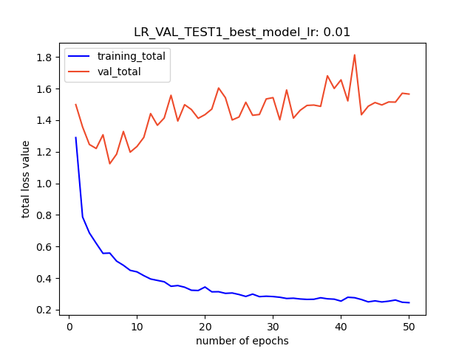
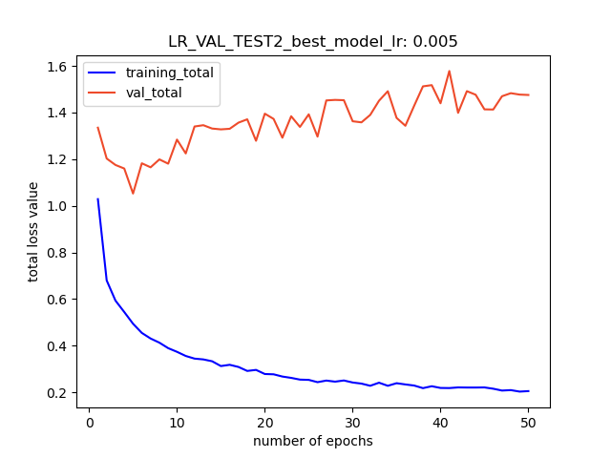
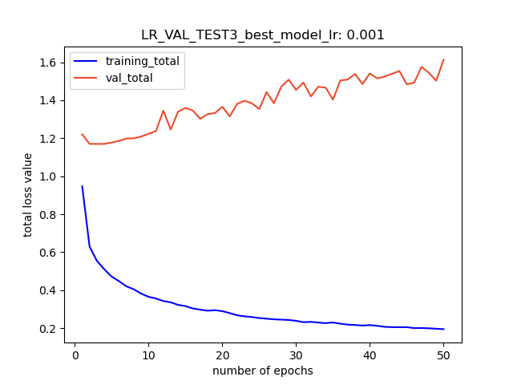
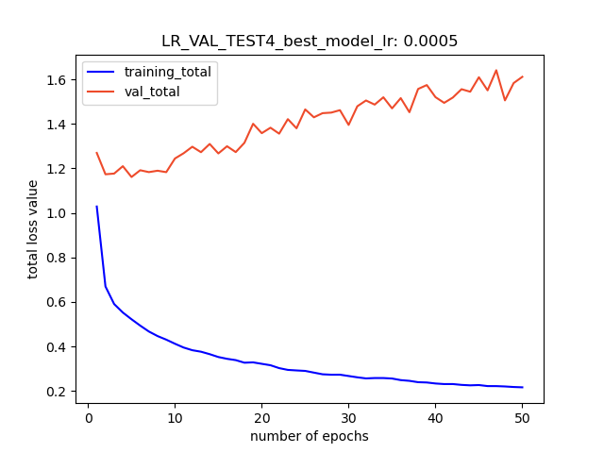
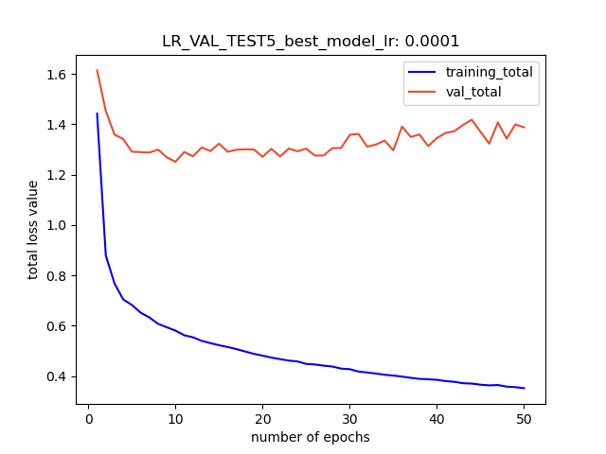
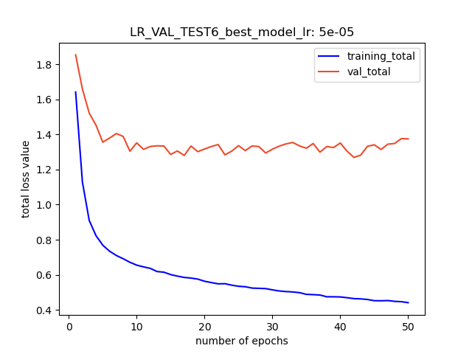

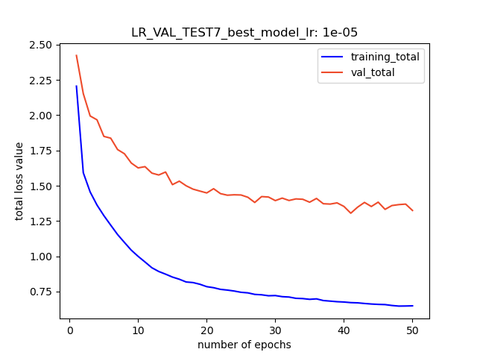
Best Models:
0.01 → lv = 1.239 @ epoch 6
0.005 → lv = 1.052 @ epoch 5
0.001 → lv = 1.170 @ epoch 3
0.0005 → lv = 1.162 @ epoch 5
0.0001 → lv = 1.251 @ epoch 10
0.00005 → lv = 1.269 @ epoch 42
0.00001 → lv = 1.305 @ epoch 41

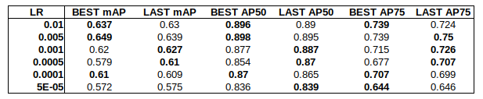
AP results for best and last models form above plots

In the following plots the total loss and losses produced by the Mask R-CNN are presented. The following losses are:
- total: The sum of all losses
- classifier: loss for classification
- box reg: the loss for bounding box generation in RCNN
- mask : mask loss
- Objectness: loss for classification in RPN
- rpn box reg: loss for bounding box generation in RPN
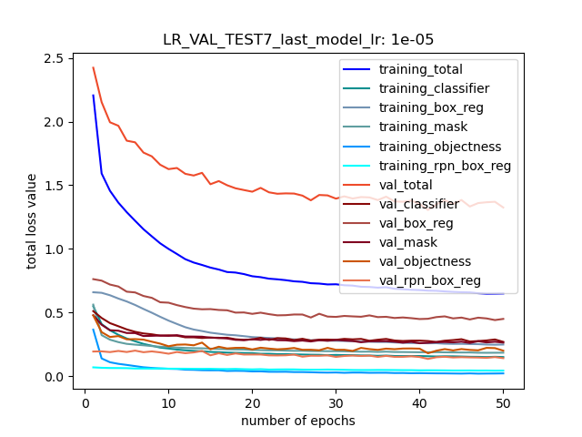
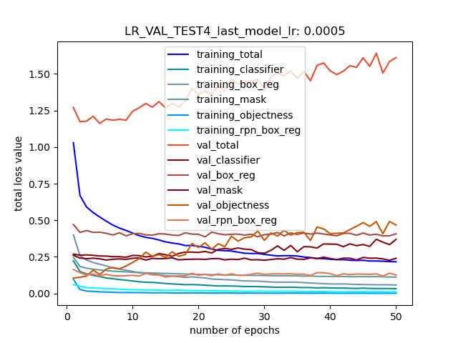

lr 0.01
best
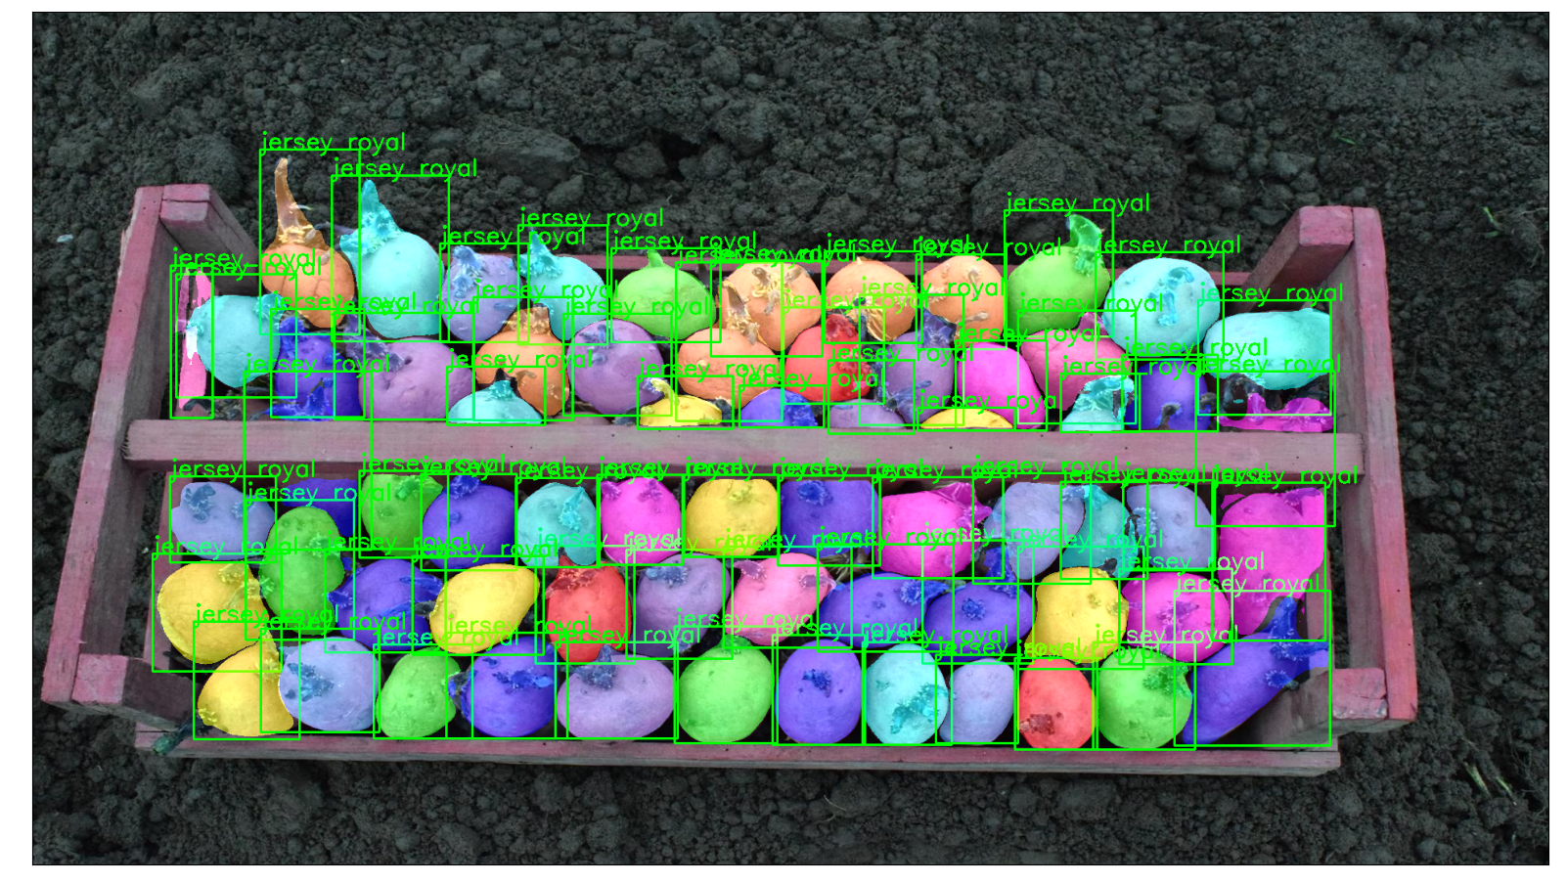
last
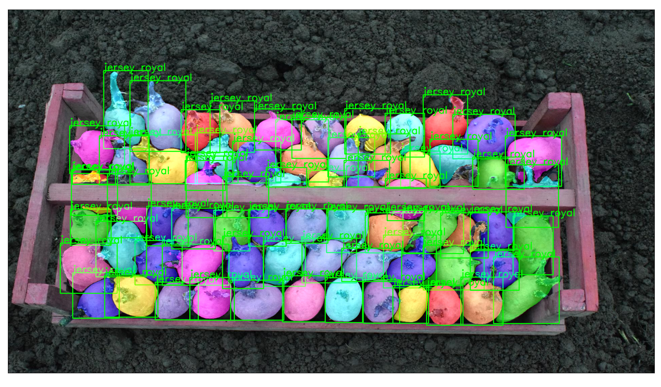

lr 0.00005
best
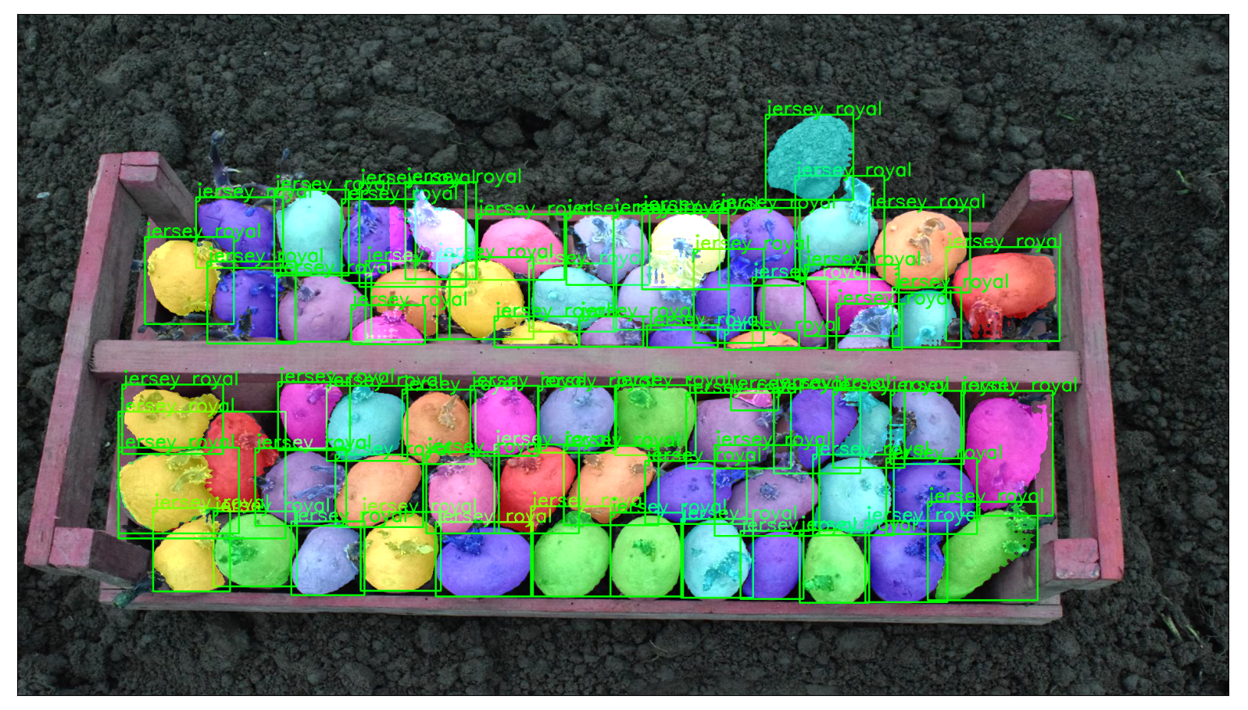
Last:
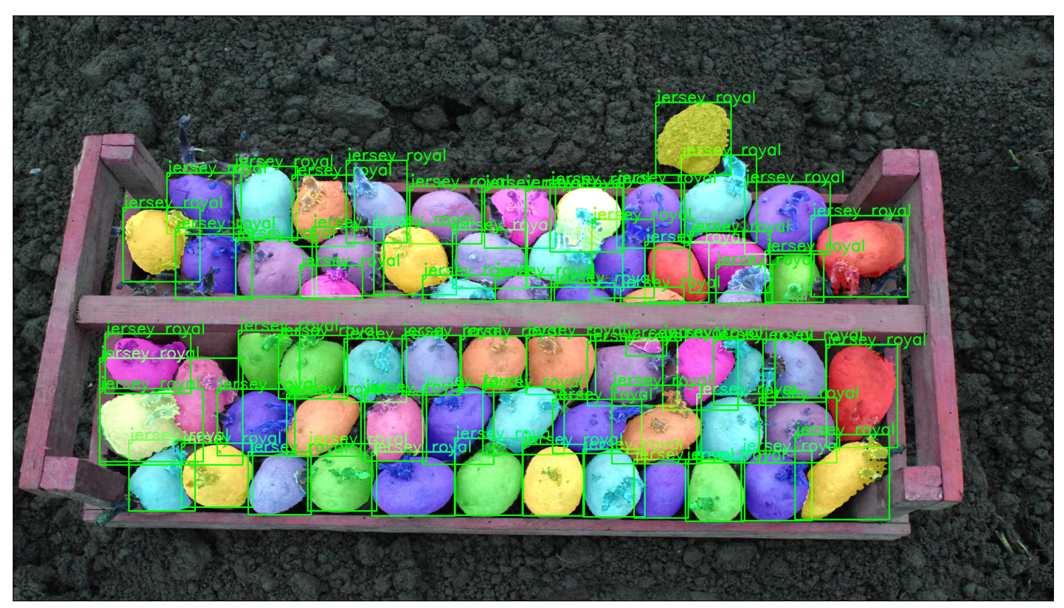

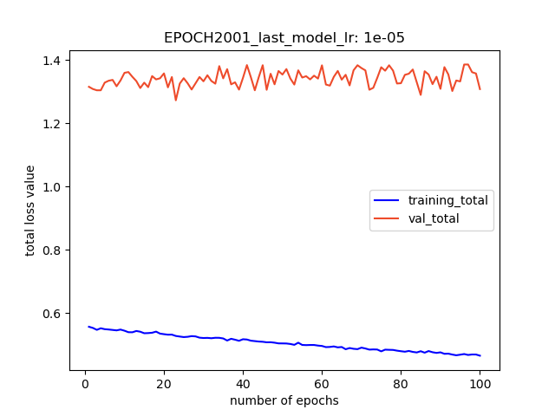
lr 0.00001 over 200 epochs
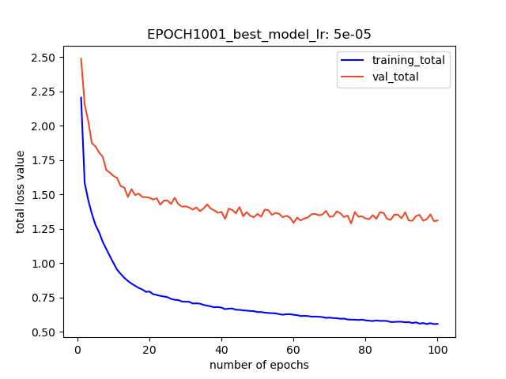

Best model lv = 1.272 @ epoch 123

best model results, AP = 0.602, AP50 = 0.855, AP75 = 0.670
last model results, AP = 0.606, AP50 = 0.858, AP75 = 0.693

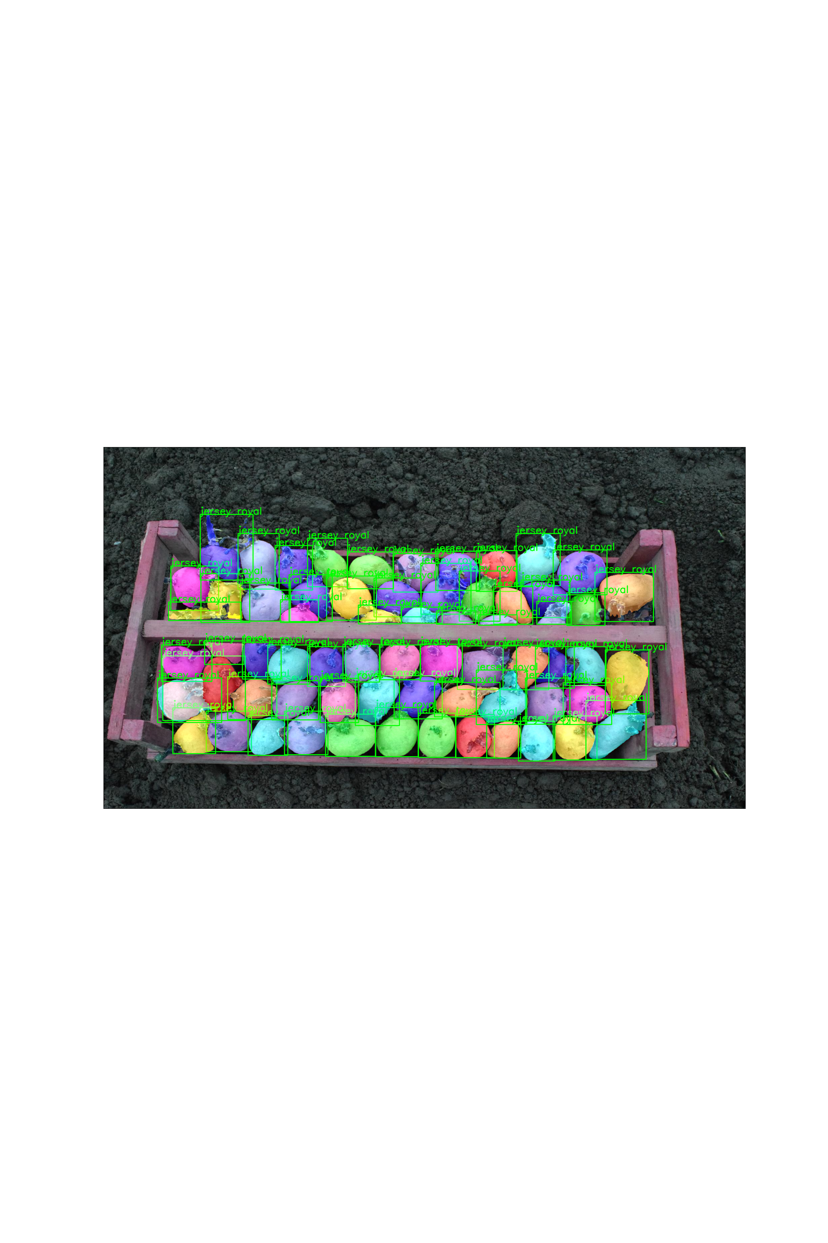
last model

best model

best model further training on 100 epoch
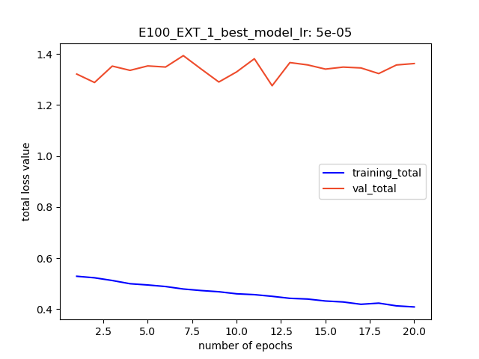

best model base 100: lv = 1.288 @ epoch 76
best model further : lv = 1.275 @ epoch 93

base best model results, AP = 0.585, AP50 = 0.843, AP75 = 0.650
base last model results, AP = 0.596, AP50 = 0.852, AP75 = 0.670

further best model results, AP = 0.610, AP50 = 0.868, AP75 = 0.687
further last model results, AP = 0.611, AP50 = 0.868, AP75 = 0.700

best model
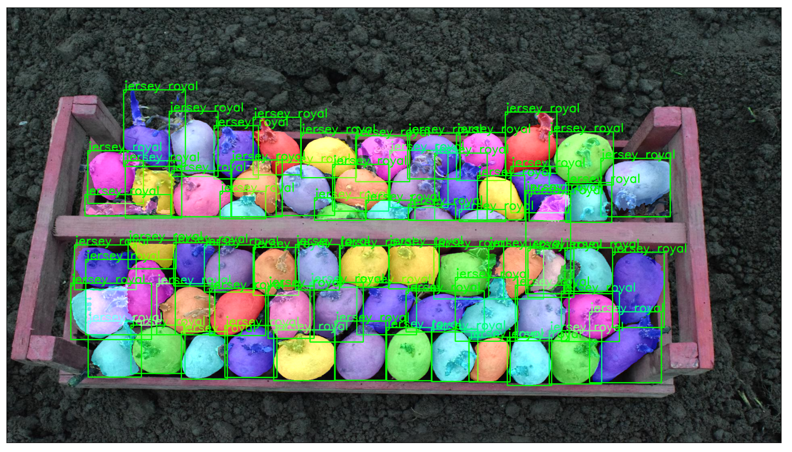

last model


